**Screens for Week 3**

Kimberly Sultan

27Mar2019

Databases are loaded in local SQL Server “kimbe”.

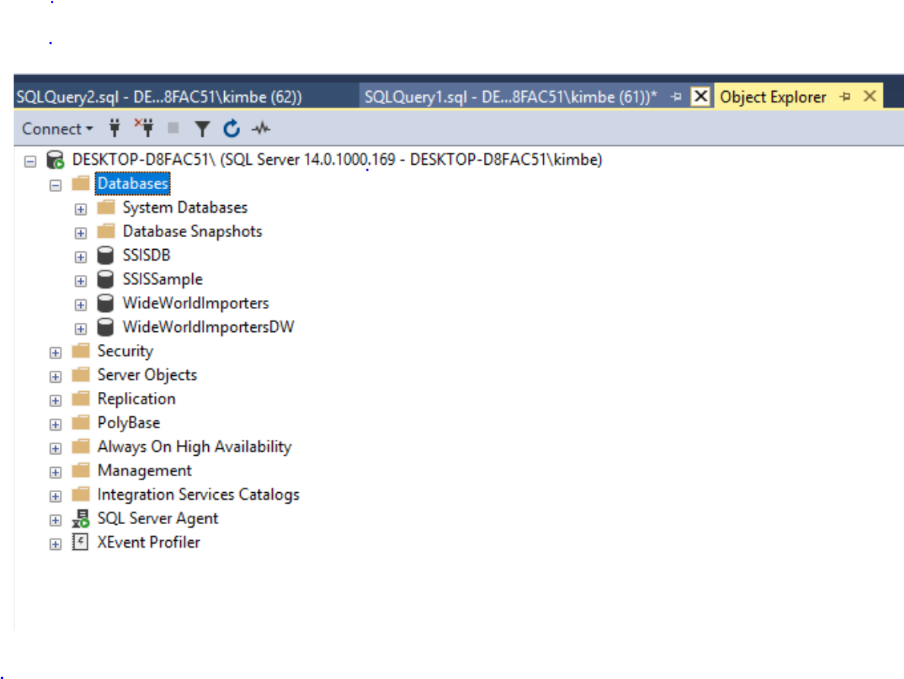

<https://docs.microsoft.com/en-us/sql/samples/wide-world-importers-perform-etl?view=sql-server-2017>

This link explains the process for using package DailyETLMain to add updates of data to the database/DW.

Use the WWI_Integration ETL package to migrate data from the WideWorldImporters database to the WideWorldImportersDW database as data changes. The package is run periodically (usually daily).

The package ensures high performance by using SQL Server Integration Services to orchestrate bulk T-SQL operations (instead of separate transformations in Integration Services).

Dimensions are loaded first, and then Fact tables are loaded. You can rerun the package any time after a failure.

For the source code to re-create the sample database, see [wide-world-importers](https://github.com/Microsoft/sql-server-samples/tree/master/samples/databases/wide-world-importers/wwi-integration-etl).

## Install

1. Deploy the Integration Services package:
   1. In Windows Explorer, open the Daily ETL.ispac package. This launches the SQL Server Integration Services Deployment Wizard.

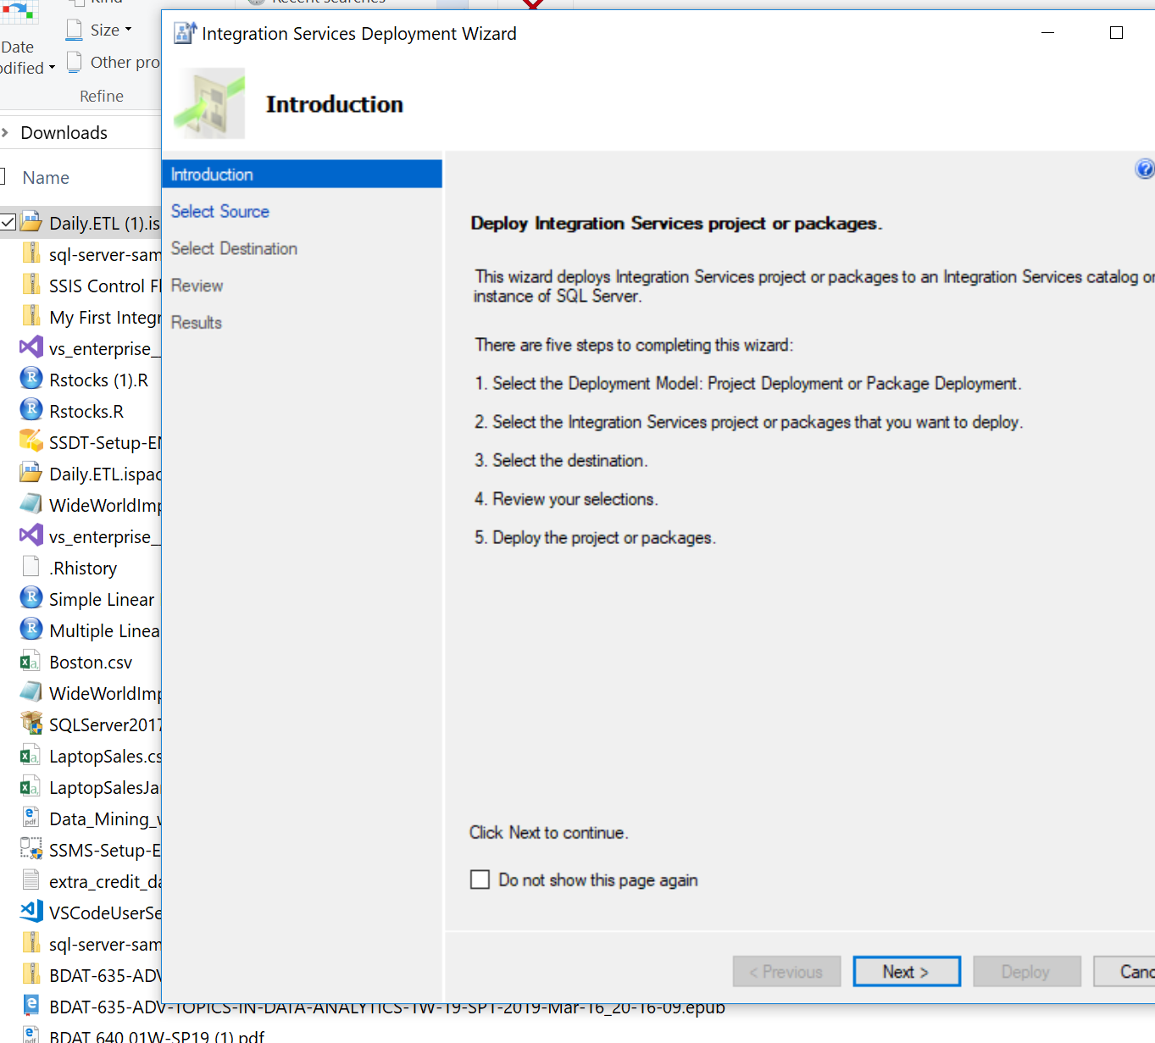

* 1. Under **Select Source**, follow the defaults for Project Deployment, with the path pointing to the Daily ETL.ispac package.
  2. Under **Select Destination**, enter the name of the server that hosts the Integration Services catalog.
  3. Select a path under the Integration Services catalog, for example, in a new folder named WideWorldImporters.
  4. Select **Deploy** to finish the wizard.

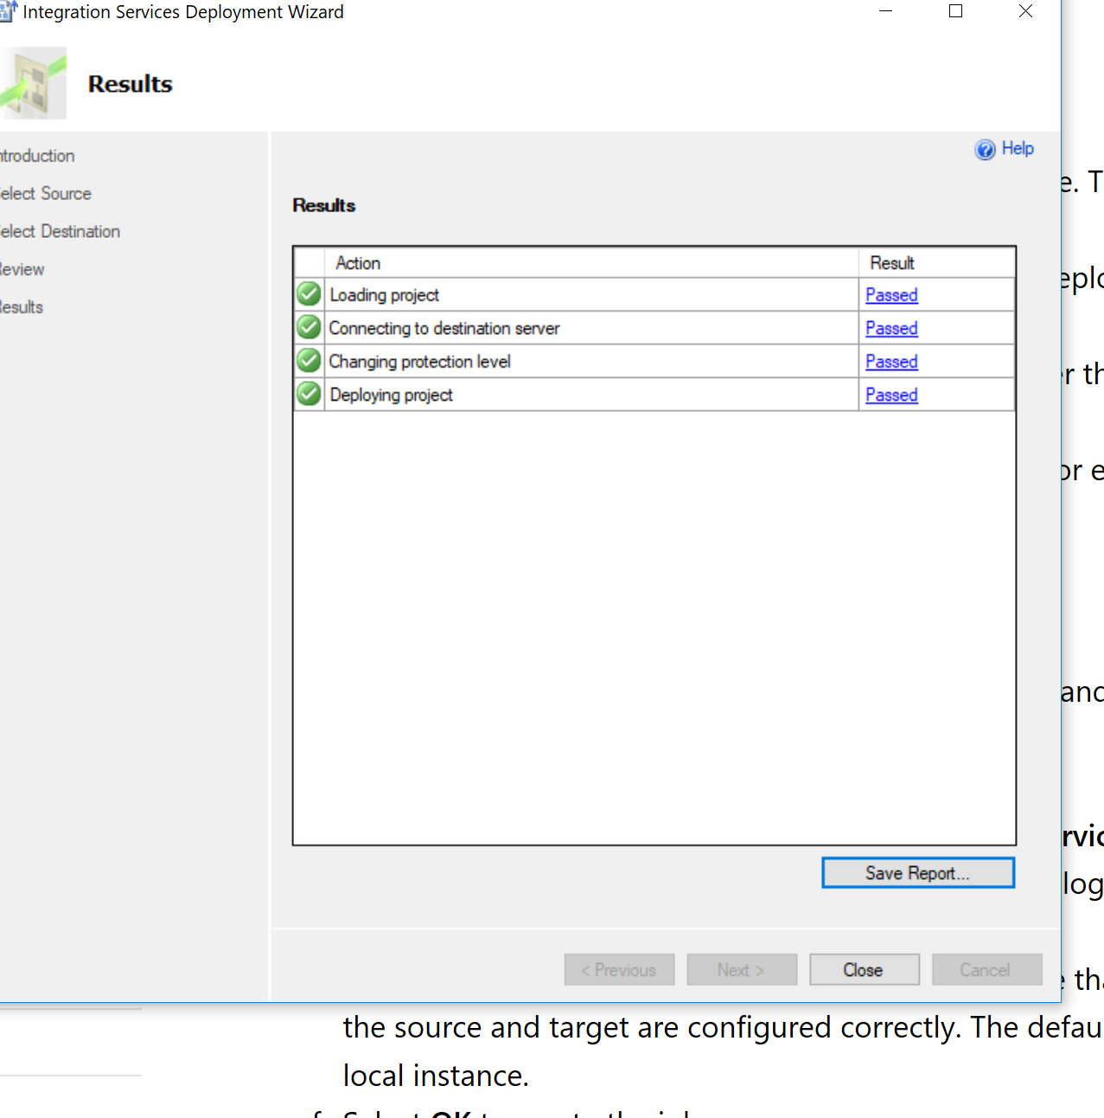

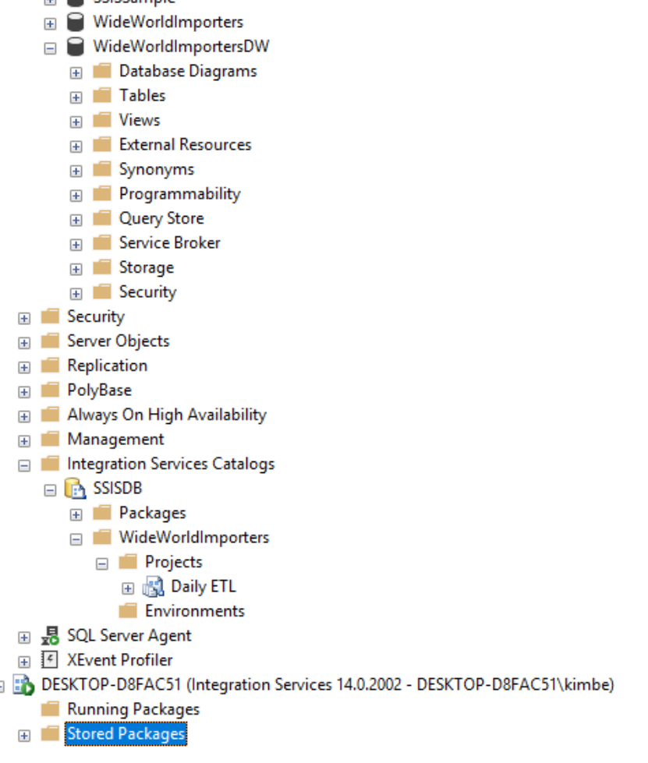

1. Create a SQL Server Agent job for the ETL process:
   1. In Management Studio, right-click **SQL Server Agent**, and then select **New** > **Job**.
   2. Enter a name, for example, WideWorldImporters ETL.
   3. Add a **Job Step** of the type **SQL Server Integration Services Package**.
   4. Select the server that has the Integration Services catalog, and then select the Daily ETL package.
   5. Under **Configuration** > **Connection Managers**, ensure that the connections to the source and target are configured correctly. The default is to connect to the local instance.

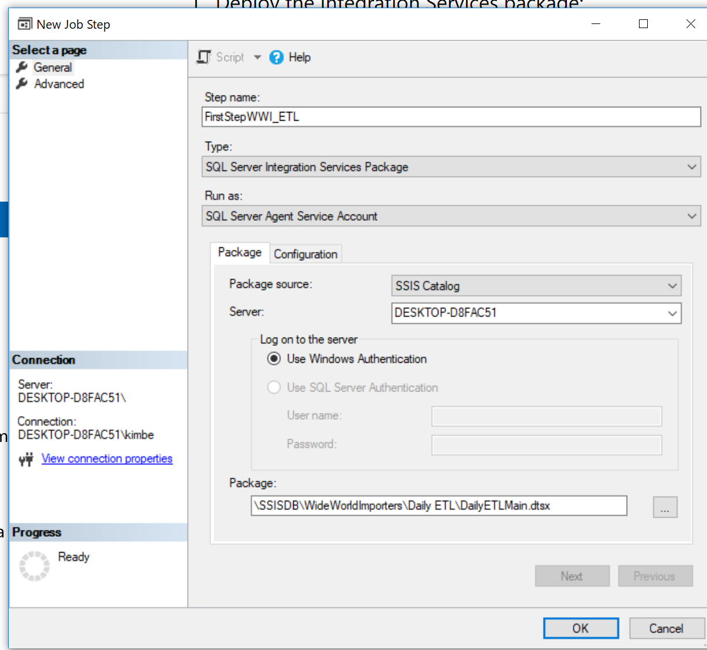

* 1. Select **OK** to create the job.

1. Execute or schedule the job.

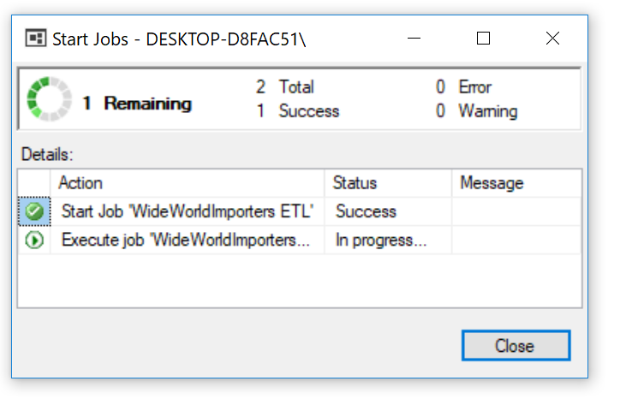

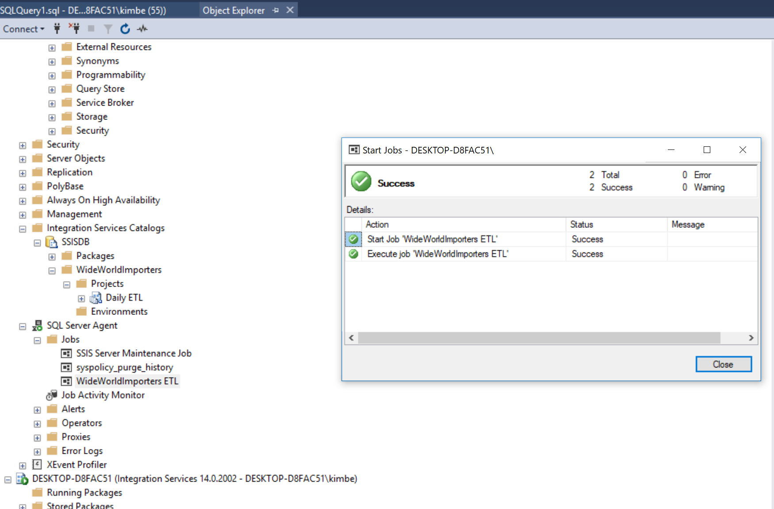

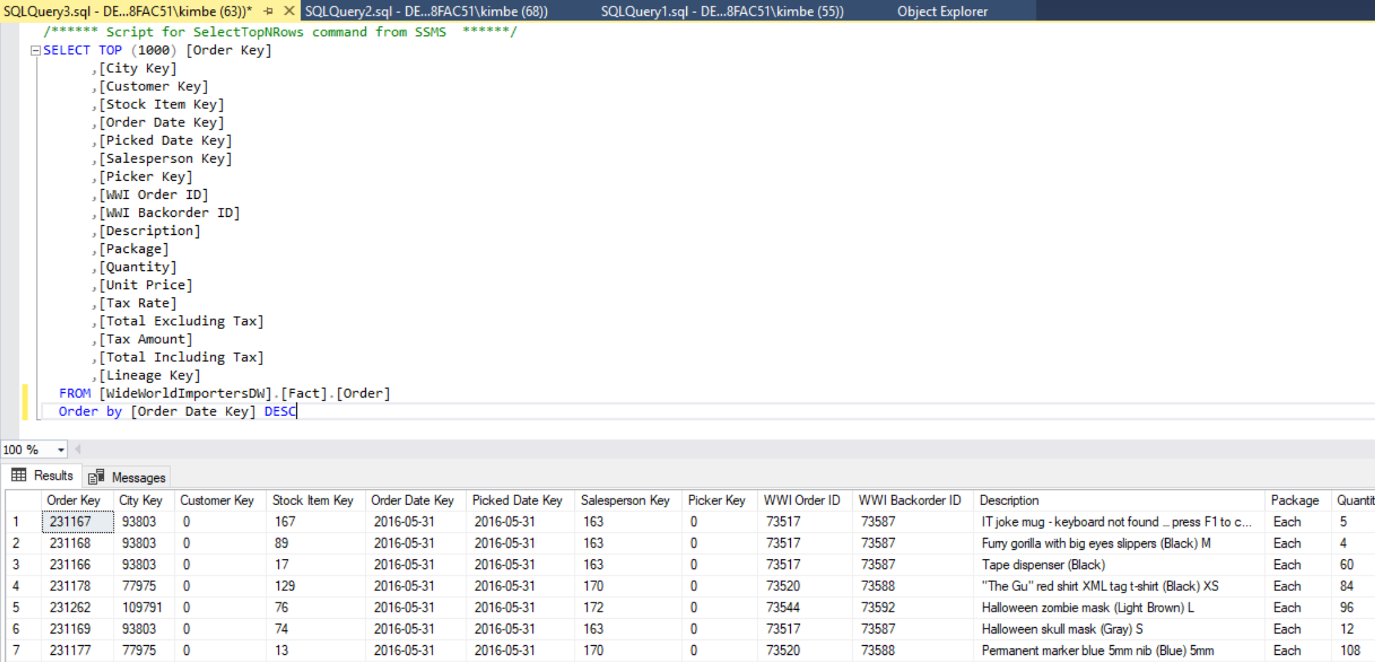

[**wwi-ssis**](https://github.com/Microsoft/sql-server-samples/blob/master/samples/databases/wide-world-importers/wwi-ssis)

SQL Server Integration Services (SSIS) project for the Extract, Transform, and Load (ETL) process that takes data from the transactional database WideWorldImporters and loads it into the WideWorldImportersDW database.

